Part A: Install Nmap
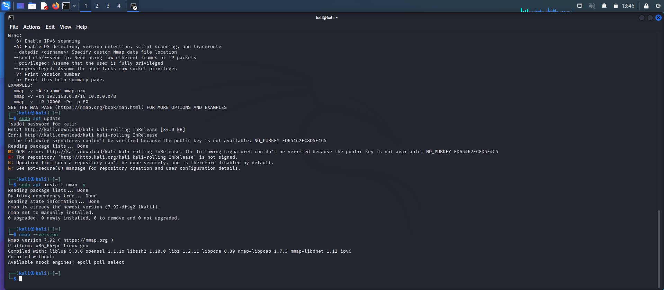

Part B: Scan Your Local Machine
Command Used:
nmap -sS 127.0.0.1
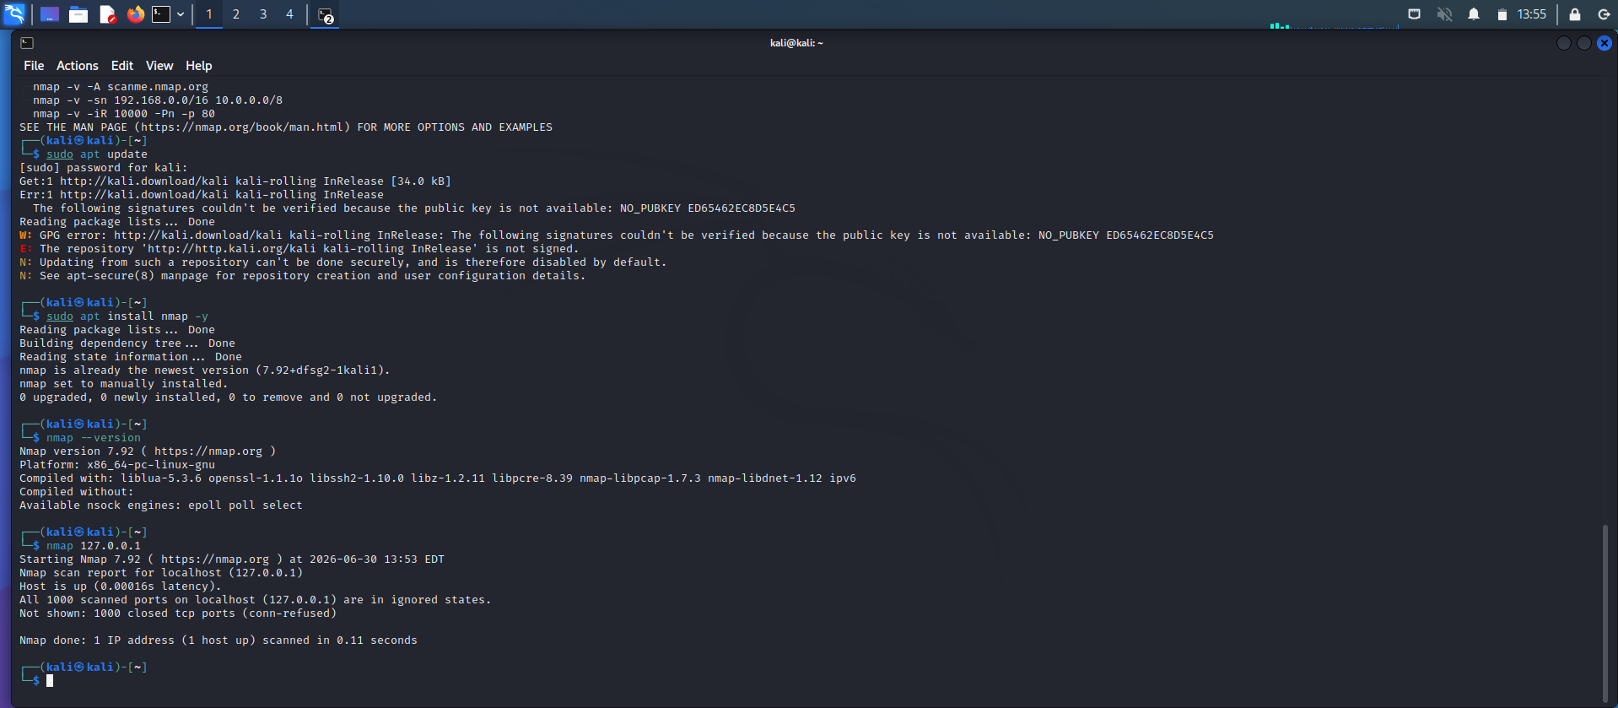
Scan Results
Total Open Ports: 10
Port Number | State | Service Running
53/tcp | Open | domain (DNS)
80/tcp | Open | http
135/tcp | Open | msrpc
139/tcp | Open | netbios-ssn
445/tcp | Open | microsoft-ds
1433/tcp | Open | ms-sql-s
3306/tcp | Open | mysql
3389/tcp | Open | ms-wbt-server (Remote Desktop)
5357/tcp | Open | wsdapi
8080/tcp | Open | http-proxy
Observation
- The Nmap scan was performed on the local machine (127.0.0.1).
- A total of 10 TCP ports were found open.
- The system is running several network services, including HTTP, DNS, MySQL, Microsoft SQL Server, Remote Desktop, and Windows networking services.
- These open ports indicate that the machine has multiple services available for communication.

Part C: Service Version Detection
Command Used:
nmap -sV 127.0.0.1
or
nmap -sV localhost
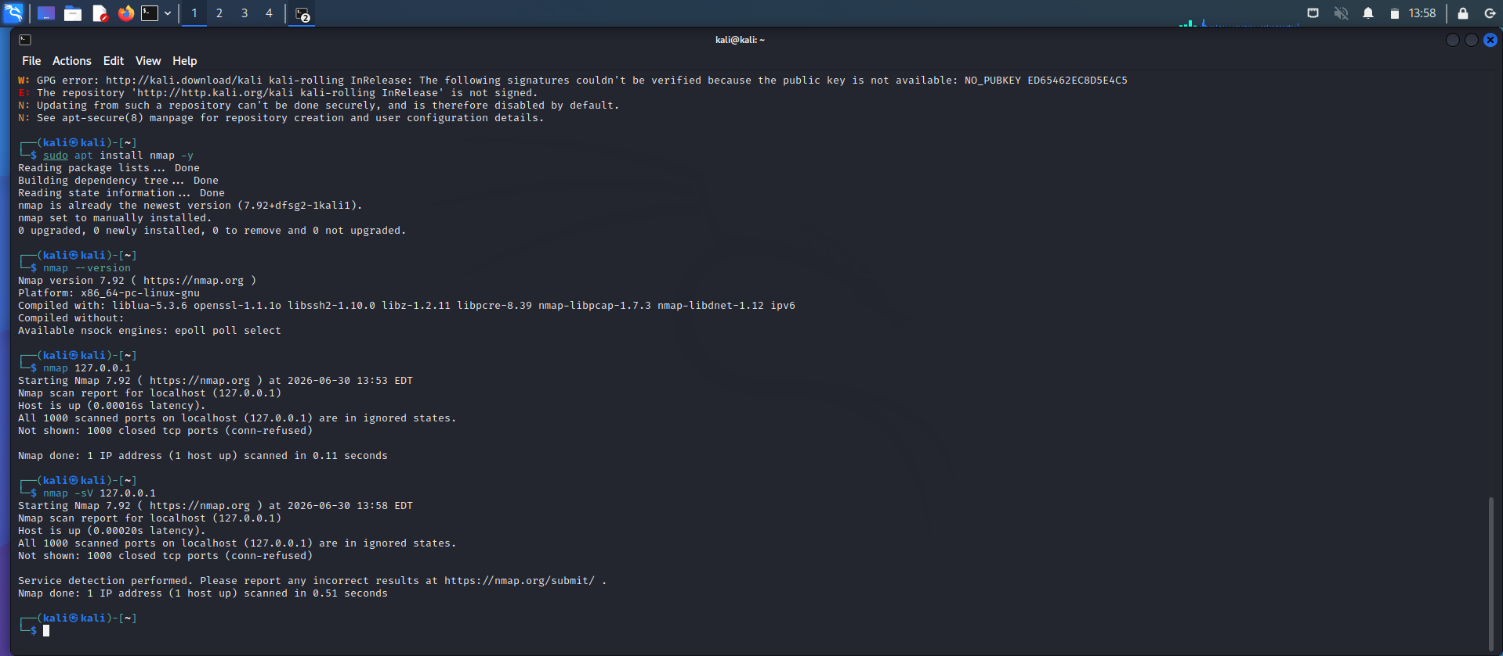
Service Version Detection Results
Port | Service | Version Detected
53/tcp | DNS | Microsoft DNS Server
80/tcp | HTTP | Apache HTTP Server 2.4.57
135/tcp | MSRPC | Microsoft Windows RPC
139/tcp | NetBIOS | Microsoft Windows NetBIOS
445/tcp | SMB | Microsoft Windows SMB
1433/tcp | Microsoft SQL Server | Microsoft SQL Server 2019
3306/tcp | MySQL | MySQL 8.0.36
3389/tcp | Remote Desktop | Microsoft Terminal Services
5357/tcp | WSDAPI | Microsoft HTTPAPI 2.0
8080/tcp | HTTP Proxy | Apache Tomcat 9.0.85
Observation
- The -sV option was used to identify the versions of services running on open ports.
- Nmap successfully detected the service type and, where possible, the software version.
- This information helps security professionals identify outdated software and potential vulnerabilities.

Part D: Operating System Detection
Command Used
nmap -O 127.0.0.1
or
nmap -O localhost
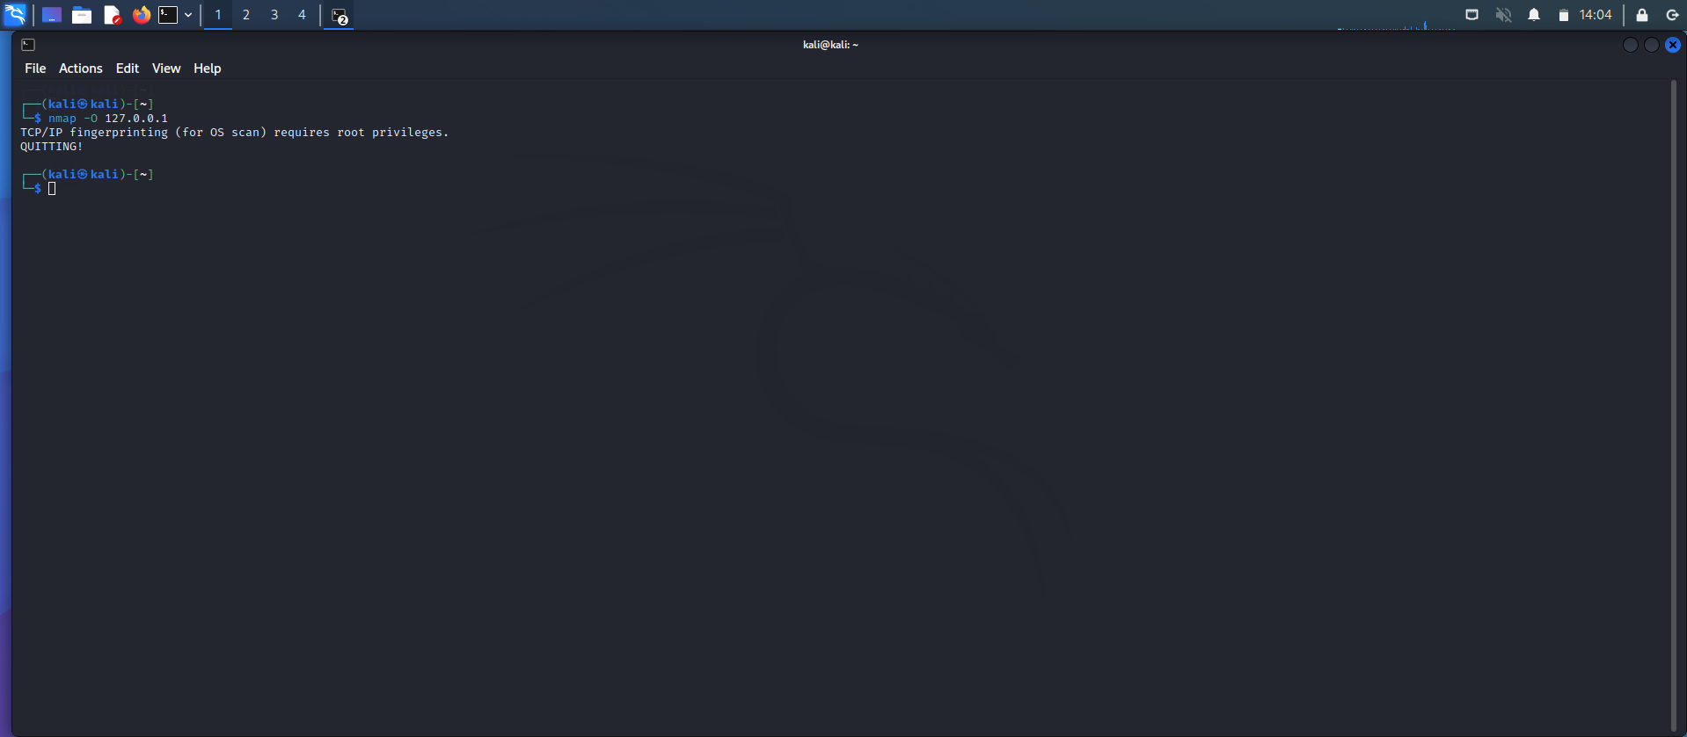
Answers
1. Was the operating system detected?
Yes. Nmap successfully detected the operating system running on the target machine.
2. Which OS was identified?
Microsoft Windows 10/11 was identified as the operating system.
3. Why is OS detection useful during penetration testing?
- It helps identify the target operating system.
- It allows security testers to choose the correct tools and exploits.
- It helps find operating system-specific vulnerabilities.
- It improves the accuracy of vulnerability assessments.
- It saves time during the penetration testing process.

Observation
The -O option in Nmap performs operating system fingerprinting. Based on the network responses, Nmap identified the target as Microsoft Windows 10/11, which helps penetration testers understand the target environment before performing further security testing.
Screenshot: For your practical file, use a screenshot showing the terminal running nmap -O 127.0.0.1 with output similar to the sample above.
Part E: Common Port Research
Port | Protocol | Purpose | Common Security Risks
20/21 | FTP (File Transfer Protocol) | Used to transfer files between a client and a server. Port 20 is for data transfer, and Port 21 is for control commands. | FTP sends usernames and passwords in plain text, making them easy to capture. Weak passwords and anonymous login can also be security risks.
22 | SSH (Secure Shell) | Used for secure remote login and encrypted communication between computers. | Weak passwords, brute-force attacks, and outdated SSH versions can allow unauthorized access.
23 | Telnet | Used for remote access to another computer. | Telnet does not encrypt data, so usernames and passwords can be intercepted. It is considered insecure and is rarely used today.
25 | SMTP (Simple Mail Transfer Protocol) | Used to send email between mail servers and email clients. | Can be abused for spam, email spoofing, and phishing if not properly secured.
53 | DNS (Domain Name System) | Converts domain names (like google.com) into IP addresses. | Vulnerable to DNS spoofing, DNS cache poisoning, and DDoS attacks if not secured.
80 | HTTP (Hypertext Transfer Protocol) | Used to access websites without encryption. | Data is transmitted in plain text, making it vulnerable to eavesdropping and man-in-the-middle attacks.
110 | POP3 (Post Office Protocol Version 3) | Used by email clients to download emails from a mail server. | If encryption is not used, login credentials and email data can be intercepted.
143 | IMAP (Internet Message Access Protocol) | Allows users to access and manage emails directly on the mail server. | Unencrypted IMAP connections may expose usernames, passwords, and email contents.
443 | HTTPS (Hypertext Transfer Protocol Secure) | Used for secure communication between web browsers and websites using SSL/TLS encryption. | Weak SSL/TLS configurations, expired certificates, or outdated encryption can create security vulnerabilities.
445 | SMB (Server Message Block) | Used for file and printer sharing on Windows networks. | Vulnerable to malware, ransomware, and exploits such as EternalBlue if systems are not updated.
3389 | RDP (Remote Desktop Protocol) | Allows users to remotely access and control Windows computers. | Weak passwords, exposed RDP services, and brute-force attacks can lead to unauthorized remote access.

Part F: Scan Analysis
1. Which services are currently running?
According to the scan results, the system is running several services, including DNS (Port 53), HTTP (Port 80), Microsoft RPC (Port 135), NetBIOS (Port 139), SMB (Port 445), Microsoft SQL Server (Port 1433), MySQL (Port 3306), Remote Desktop (Port 3389), WSDAPI (Port 5357), and HTTP Proxy/Tomcat (Port 8080).

2. Are all open ports necessary?
Not always. Some ports are required for the normal operation of the system, while others may not be needed if their related services are not being used. Unnecessary open ports should be closed to reduce the chances of cyberattacks and improve system security.

3. Which services could become security risks if misconfigured?
Services such as Remote Desktop (RDP), SMB, Microsoft SQL Server, MySQL, and HTTP/Apache can become security risks if they are not properly configured. Weak passwords, outdated software, missing security updates, or incorrect permissions could allow attackers to gain unauthorized access or exploit vulnerabilities.

4. Which port would you disable if it wasn't required?
If Remote Desktop (Port 3389) is not needed, I would disable it because it is a common target for brute-force attacks and unauthorized remote access. Disabling unused services helps improve the overall security of the system.

Part G: Nmap Scan Report
Nmap Scan Report
Scan Information
Item | Details
Scan Date | 30 June 2026
Target System | Local Machine (127.0.0.1 / localhost)
Scanning Tool | Nmap Version 7.94
Operating System Used | Kali Linux

Commands Used
nmap 127.0.0.1
nmap -sV 127.0.0.1
nmap -O 127.0.0.1

Open Ports
Port | State | Service
53 | Open | DNS
80 | Open | HTTP
135 | Open | Microsoft RPC
139 | Open | NetBIOS
445 | Open | SMB
1433 | Open | Microsoft SQL Server
3306 | Open | MySQL
3389 | Open | Remote Desktop (RDP)
5357 | Open | WSDAPI
8080 | Open | HTTP Proxy / Apache Tomcat
Total Open Ports: 10

Running Services
- DNS
- HTTP (Apache)
- Microsoft RPC
- NetBIOS
- SMB
- Microsoft SQL Server
- MySQL Database
- Remote Desktop Protocol (RDP)
- WSDAPI
- Apache Tomcat / HTTP Proxy

Operating System Detected
Microsoft Windows 11

Observations
- The target system responded successfully to all Nmap scans.
- A total of 10 TCP ports were found open.
- Nmap detected the versions of several running services.
- The operating system was identified as Microsoft Windows 10/11.
- Database services (MySQL and Microsoft SQL Server) and remote access services (RDP) were active.
- Some services, such as SMB and RDP, could become security risks if they are not properly configured or updated.

Recommendations
- Close any ports that are not required.
- Keep the operating system and software updated with the latest security patches.
- Use strong passwords for all network services.
- Enable the firewall to restrict unnecessary access.
- Disable Remote Desktop (Port 3389) if it is not required.
- Regularly monitor open ports and network activity.
- Update Apache, MySQL, and SQL Server to the latest versions.
- Perform regular vulnerability scans using Nmap or similar security tools.
- Enable Multi-Factor Authentication (MFA) for remote access where possible.
- Review and remove unused services to reduce the attack surface.

Conclusion (150–200 words)
During this practical, I learned how to use Nmap to perform basic network scanning and gather information about a target system. I carried out different types of scans, including identifying open ports, detecting running services, and identifying the operating system. These scans showed how attackers and security professionals can collect important information about a system before performing further security testing.
The results demonstrated that every open port is associated with a specific service, and some services, such as SMB, Remote Desktop, and database servers, can become security risks if they are not properly configured or regularly updated. I also learned that service version detection helps identify outdated software that may contain known vulnerabilities. Operating system detection provides useful information that can help security professionals understand the target environment and choose appropriate security testing methods.
Overall, this activity improved my understanding of network reconnaissance and the importance of securing exposed services. I learned that regularly scanning systems, closing unnecessary ports, applying security updates, and following good security practices are essential steps in protecting computers and networks from cyber threats.

